INTEGRATIVE COURSE IN PSYCHOLOGY (ICOPSYCH)

ANALYSIS ON THE RESULT OF POST-TEST EXAMINATION IN ABNORMAL PSYCHOLOGY
APRIL 26, 2025

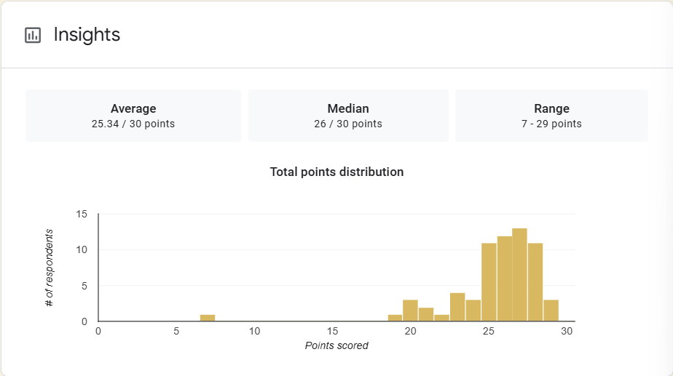

1. Mean Score: A mean of 25.34 suggests that, on average, students scored very well, achieving approximately 84.5% of the total possible points.

2. Median Score: A median of 26 means that half the students scored above or equal to 26 and half scored below. Since the median is slightly higher than the mean, it suggests a slightly left-skewed distribution (a few lower scores pulling the average down).

3. Range: A low of 7 and a high of 29 indicates a wide variability in performance, with some students struggling significantly while others nearly achieved perfect scores.

Interpretation Summary:

-The overall performance is strong, with high mean and median scores.

-The slightly lower mean than median suggests a few students scored significantly lower, affecting the average.

-The wide range highlights that while most students performed well, there is a notable performance gap among individuals.

RATIONALIZATION:

DIFFICULT QUESTIONS:

